An Approach to Dialogues

Green Economy Coalition

Stuart Worsley
October 2017

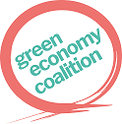

The ideas in this paper are have been informed through joint work with Danny Burns, with whom Stuart has co-authored and published these in Danny Burns and Stuart Worsley (2015) Navigating Complexity in International Development, Rugby, UK: Practical Action Publishing

Table of Contents

Mobilising National Action Through Dialogues 3
Defining Green Economy Dialogues 3
The Three Tier Dialogue Arrangement 6
Micro Level Dialogues 6
Seeding Micro Level Dialogues 6
Braiding and Converging Micro Level Dialogues 9
Meso Level Dialogues 9
Macro Level Dialogues 10
Global Level Dialogues 10
Downward Knowledge Flow 10
Mapping out Systems 12
Some important principles 12
Systems need to be seen from multiple perspectives: 12
Inquiry process itself may involve multiple methods 12
It is necessary to subject meaning making to collective scrutiny 12
Systemic mapping 12
System dynamics constantly change, and this needs to be captured: 13
Stage 1: Multi-stakeholder inquiry 13
Stage 2: Construction and analysis of ‘messy’ issue and relationship maps 15
Stage 3: Construction of distilled system dynamic maps 19
Stage 4: Validation and resonance testing of issues 19

Mobilising National Action Through Dialogues

Defining Green Economy Dialogues
The Green Economy Coalition (GEC) is working to accelerate global transition to green, fair and inclusive economies, and has defined a strategy to make this happen. One of the core elements of this strategy is the mobilisation of action through dialogue. Here, GEC works to “create national social movements and across the world and convene existing actors to champion the green economy transition and specific green economy initiatives.”
Such dialogues have alternatively been labelled “National Dialogues.” Since this expression has a specific meaning, it is worth being clear about GEC intentions with respect to dialogue.
The term National Dialogues was conceived within the field of peace building. Here, they here have been framed around political negotiations to broaden participation and have been described by IPTI 2016 as “inclusive, multi-party negotiations in which large segments of society are represented, such as elites, political parties, organized civil society, women, youth, business, religious or traditional actors, and other relevant groups.” Such National Dialogues are typically formally-mandated public forums installed in moments of political crisis or severe tension which have a clear structure establishing rules and procedures for dialogue and decision-making. They are convened over the course of several days, weeks, or even months. They tend to be top-down processes that seek bottom up engagement.
Green Economy dialogues by contrast have been conceived of as a key catalytic instrument of the GEC to convene a soft-power basis for tackling imbalanced power structures. The GEC works to bring together stakeholders needed for change, to help them define actions that they can do towards improving their green economy, to open space to exchange experiences and develop solutions together, and to provide a platform to negotiate the changes they need to promote, and indeed to make themselves. Green Economy dialogues are a convening process where evidence-based conversations widen the diversity of perspectives. Since typical Green Economy initiatives tend to focus on government actions, the GEC seeks to involve civil society and market systems. Inclusive dialogue is the core mechanism for GEC’s work. Conversation, and joint diagnosis and action helps stakeholders look at how their economy and society link with environmental issues, and to scope what a ‘green economy’ means for them.
To foster movement-based change, GEC processes must enable such conversation at micro level, at meso level, at macro level and between all these levels.
At the micro level, dialogues around local issues foster specific actions and review consequent evidence that is directly informed by local people and their concerns. Where action is grounded in people who care to act, such dialogue is infused with energy, experience, legitimacy and imperative.
At the meso level, dialogues bring evidence of micro level action together. Dialogues enable interaction and test micro-evidence for broader resonance across the system. These indicate issues that are widely felt, but that are not always immediately obvious. Testing narratives for resonance begins to reveal system patterns and attractors, and give clues as to actions that might challenge deeper underlying causes of concern.
At the macro level, dialogues bring together national policy actors to use resonant issues revealed through micro and meso level dialogues, to undertake policy experiments. Based on an understanding of what is happening to enable Green Economy across the nation, such policy action has increased likelihood of making smart choices. Action at this level will influence the space at micro level, and either enable or disable local action. Continuous engagement with the meso-level dialogues can quickly provide evidence of policy action. For policy makers, this is attractive as it provides a mechanism for real-time policy feedback.
At a global level, GEC mobilises its membership and its member GE country hubs to pull policy levers they can best reach to support GE transition. Informed by national macro-level dialogues and evidence of policy action, this collective movement has a unique capability to inform global action.
At all levels, external knowledge is brought into dialogue processes in ways that are considered and infused with judgement. As opposed to using global expert knowledge to drive action, dialogues offer space for global, national and local knowledge to interact. The choice of knowledge taken up and used however rests with those who chose to act.
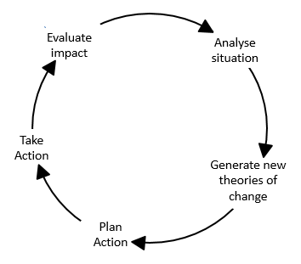
For the purposes of the GEC, Green Economy Dialogues therefore refer to a process of ongoing action, reflection, analysis and generation of new change theory, starting at micro levels, and rising to meso, macro and global levels. Green Economy Dialogues are about exchanging and engaging perspectives and experiences between people. Constructed around an action research framework, people in conversation explore issues that interest them, decide on what to do about them, and plan actions. After such conversations, actions ensue based on the volition of those moved to act. Such activism and action leads to consequence which is accompanied by evidence. While reflection of such evidence occurs within activists themselves, periodic conversations within and between action groups foster a process of analysis. Asking “what worked” and “what did not work” validates or challenges theories of change that are accordingly adapted. New actions planned based on such evidence give rise to new evidence, and so on. Each group that gathers around an issue and follows an action cycle (figure 1) creates a strand of enquiry. Multiple actions by many groups form many strands. Evidence formed by actions in each strand grow through subsequent iterations in an ongoing process. This is informed in response to both the evidence that has generated for itself, and to new external knowledge introduced by GEC members and others that action groups want to take on board.
Figure 1
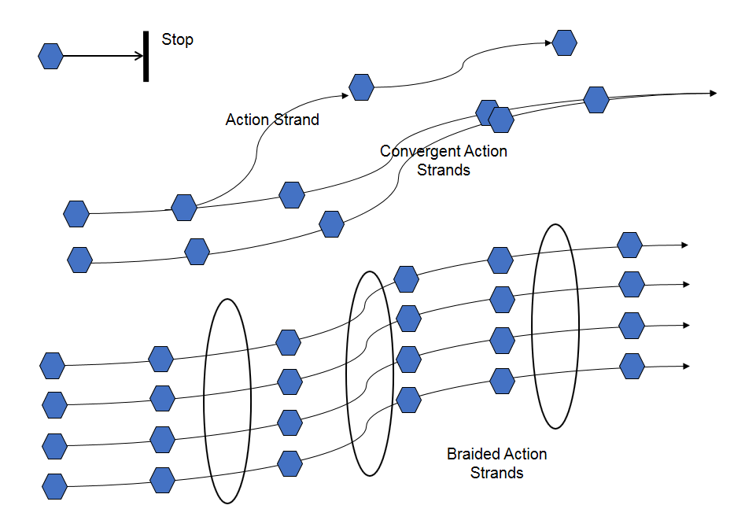
Strands of enquiry can continue alone in unconnected ways, each generating specific learning. As well as facilitating this, the Green Economy Dialogue process works to facilitate conversations between enquiry strands to cross fertilize experiences between groups so that they can mutually influence one another. Such facilitation may braid separate strands into clusters with weak ties³ or cause two or more strands to converge into a single enquiry. It can of course continue to support lone strands. Some strands may simply stop when they have done what they wanted to do and have no more reason to continue. This is either because the groups involved fizzle out because the enquiry does not do what was hoped for. Alternatively, enquiries may ask a straightforward linear question to which there is a clear answer whose form does not prompt further enquiry. Here, enquiries stop. Convergence happens where enquiry agendas combine. This will likely be accompanied by the formation of strong ties where time, emotional intensity, intimacy and reciprocity between action groups increase. Braiding of strands happens where enquiry agendas come into regular sight of one another, and where weak ties are formed. The evidence of actions in one strand is seen and processed by other action groups. Facilitated dialogue processes here enable evidence to be collectively processed (See Figure 2).
Figure 2
According to Granovetter 1973, weak ties have particular cohesive power. Whereas strong ties have stronger mutual effect on connected groups, this is confined to small well-defined networks. By contrast, weak ties open-up relationships between groups and exploit social structures that are not defined by primary groups. In such networks, small-scale interaction becomes translated into large scale patterns that in turn feed back into small groups.
For the purposes of this paper therefore, Green Economy Dialogues refer to the whole process of facilitating action research at micro, meso and macro levels (figure 1), convening inter group conversations to test evidence for resonance, and the use of that evidence in national and global policy forums.
Dialogues embody important principles as follows
- Dialogues generate ideas. Interlocutors in conversation bring ideas together and use these and their own perspectives and experiences to develop ideas, and frame new ones.
- Dialogues foster participation. The act of conversation reveals people’s interests and energies. Facilitated well, good conversation leads to action by many people.
- Dialogues foster learning. Following action, conversations with people involved enable reflection and evaluation of action and its consequences. A moment of deliberate pause and conversation stimulates thoughtful reviews of what worked and what did not.
- Dialogues foster legitimate active organisation. When people converse and purposefully explore what they can do about issues that are important to them, action groups form. Their form and actions are subscribed to by people who are affected, conferring legitimacy.
- Dialogues foster network function. Conversations between action groups enable lessons learned in these groups to become visible to one another. This gives rise to imitation, avoidance of pitfalls, collaboration or convergence. Small-scale interaction becomes translated into large scale patterns, and these in turn feed back into small groups. Fostering weak ties builds relations between groups.
- Dialogues make for smart policy. Evidence generated through local action-fed conversations provide important insights for policy makers. Conversely, policy discussions and actions provide important insights and opportunities for citizens and their groups. Dialogue processes can foster inter level conversations through the exchange of evidence.

The Three Tier Dialogue Arrangement
Tying these ideas together in a clear structure will enable dialogue within and between levels to connect. Dialogues occur at three levels, namely the micro, the meso and the macro.

Micro Level Dialogues
Micro level dialogues are perhaps the most important level to get right. These occur at specific locations where groups of concerned people become active in addressing issues that concern them. Issues that arise are typically local problems that people want to address, or opportunities that they want to exploit.

Seeding Micro Level Dialogues
Effective dialogues at the local level can be seeded through a process called systems inquiry. This is different to interview questioning or focus group facilitation. Using a team of action research facilitators, inquiries take a few days to walk through a system, ask questions and observe what is going on. Using open ended questions, inquiries explore issues that they understand to be important in that context. Using the local people, the process identifies broad issues and deploys several teams of two or three people to find out what people are saying about these issues.
Inquiry based questioning works to enable people to tell the stories that they want to tell and guide their story telling towards issues that relate to Green Economy. Inquiry will reveal factual and specific information, the issues that are important to people being spoken with, and the issues that warrant further exploration. Finding out some of this is necessary at the beginning of the process to properly understand the context before people tell their stories. However much will emerge within the stories and can be probed as people talk. Some information can be asked of at the end of the process. A balance needs to be struck here. Inquiries are not a space for people to go off on tangents which have no bearing on the issues, yet when people are allowed space to tell their stories, they reveal new and important issues, and what is most important to them.
Inquiries require astute observation, looking for issues that are significant. For example, it is not insignificant that there are a lot of disabled people in fishing communities where fish bombing is practiced. This observation might open a line for inquiry. Inquiries need to be sensitive to conflicts, conflicts of interest, differences in perception in relation to others inquired with, underlying assumptions that seem to be guiding opinions, behaviours and actions of people, and possible opportunities emerging from inquiry conversations.
Experienced action research facilitators can process a lot of information in the moment, so that promising lines of inquiry can be pursued as they emerge. Taking time to reflect during and after conversations can identify assumptions, data which contradicts other statements and so on. It is not possible to see everything at the time, so analysis needs to take place after each day’s inquiry. This may cause revisits to certain stakeholders to probe further, or indicate the need for a different inquiry.
Detailed notes need to be taken. Inquirers should learn to take notes while facilitating discussion. It is important to catch issues as far as possible in the words of those that say them, without placing a “researcher” interpretation on them.
At the end of the process, there will be a lot of notes that can be translated into issue and relationship maps to provide a visual overview. At first these maps are messy. This is a participatory process that involves everyone in the inquiry around a canvas of white paper on a large wall.
The primary focus of the maps are issues (as opposed to stakeholders). We are looking for information and insight to help to explain how and why these issues exist. The issues will relate to many stakeholders across the maps and responses may involve many actors in relation to each issue. It is important therefore that issues are the defining axis because they always lead to the agents. By contrast, focusing on the agents don’t always lead to the issues.
The aim of maps is to understand the complex dynamics of the system, to understand how issues relate to other happenings. They describe cause-effect relationships, feedback loops and patterns. Frequently issues are comprised of multiple interacting cause-effect relationships.
Constructing maps requires a mixture of free creativity and discipline. The main discipline is agreement on colours and symbols to denote different things. Links between actors denote the strength of relationships, on which symbols can denote points of conflict, areas of disagreement, blockages or opportunity. Photographs and detailed stories can illustrate context and issues. It is crucial that maps describe what people say, not our constructs. An expert, for example, might be shocked at the state of something and map this as an issue but this may barely get a mention because people see other things as being worthier of attention. This does not stop researchers adding their own reflections as inquiry questions, but these should not be confused with “data” from the field.
Analysis of maps then looks to explore issues, connections, cause effect relationships, patterns, power relationships, system dynamics and social norms, contradictions and paradoxes, energy, dynamics that keep system balance within a particular pattern of attractors, system change, issues that cross into other systems, the unexpected and potential solutions.
The third stage of the process is to create distilled system dynamic maps which show how things relate to each other, cause each other, trigger change etc. These can depict small aspects of the system that seem ripe for working on, or they can be simplified depictions of a larger process.
Group discussion around this map will attract different stakeholders to different issues. It becomes attractive to activists to see the connections and make choices about what they can do within the overall picture, cognisant that there are also other people taking other actions as well.
An example of this process might be as follows:
In a small fishing community, a GE inquiry process has mapped out the dynamics surrounding the use of fish bombs along the Warkapi coast line. Some people are using bombs to catch fish because it is easy an easy way to get a lot of fish quickly. Fish bombs are being constructed out of dynamite that is available from old World War 2 unexploded ordinance that litters the reefs and shores of the islands around. A cottage industry has developed where explosives are easily available. Fish bombs are easy to make using old beer bottles, explosive and a fuse made from a rag soaked in petrol. Local shore based fishing is being affected as coral reefs are being destroyed, and fishermen are having to travel further along the coast or to more distant reefs to find enough fish to sell. While there is a lot of talk about the destruction happening to the reefs, the immediate need for income means that enforcement is politically difficult. Some people are making quite a bit of money out of fish bombing. In the market place, fish prices are low and consumers are glad to be able to buy cheap fish. However, bombed fish, although in fact fresh, appear old. Their gills are brown and the flesh is not as turgid as usual, and handling the fish leaves indentations in the flesh. This means that bombed fish are not easily sold beyond the wet market, and tend to end up as dried salted product.
A group of people in the fishing village of Warkapi have become concerned about the future of fishing on the bay. In the group are shore based fishermen and women, small boat owners, fish sellers, members of the market management committee, two local counsellors, representatives from some local scuba diving tour companies, and medical professionals from the hospital. They think that fish bombing is bad and are looking for ways to put a stop to it. Their reasons are different, and range from concern about having to find fish further afield, declining fish stocks, bad fish quality in the market, destruction of reefs that tourists once visited and the alarming number of injuries caused through the handling of explosives. The Green Economy partner organisation has facilitated an inquiry with this group to help them think things through. The group has conducted a series of conversations with local area stakeholders, has identified some of the issues and has mapped these out. There are several options that have become apparent and different people have different ideas about what they can and should do. Four different actions have been agreed upon by four distinct groups of people.
Group 1 is made up of five local fisher folks, one doctor and the owner of the scuba company. They feel that there needs to be enforcement of national environmental laws that ban fish bombing. Their action is to try and convince the local police to put out boat patrols at night.
Group 2 is made up of seven fish sellers, two market management committee members and a local counsellor. They feel that the best way to stop fish bombing is to create market disincentives. Their action is to introduce market freshness standards in the fish market that require fish inspection before fish can be sold in the market. Fish with brown gills and whose flesh does not pass a manual turgidity test should not be allowed. They are going to make a proposal for this to the market management committee.
Group 3 is made up of four local scuba operators. They believe that if people could see the damage happening to the reefs, they would join them in supporting a ban on fish bombing. Their action is to organise boat trips for local legislators and police using their glass bottom boat to show them the destruction caused by fish bombs. They hope to be able to persuade them to take action themselves.
Group 4 is made up of some women whose family members have been disabled through fish bomb accidents, and medical staff from the local clinic. They have seen the consequences of accidents and want to make people more aware of the dangers and risks that come with fish bombing. Their action is to hold a beach campaign using drama to tell the stories of injury and the effect on people’s lives. They have decided to target the youth.
Each group takes its action, and after this reconvene to assess what happened. Using the steps defined in Figure 1, they note what happened, and discuss the implications of this. If the result is as expected, they might decide on a follow up action that will build on this. If the result was different, they might decide a new line of action based on that, or may go back to try another action that might enable them to achieve what they initially sought. In either case, a new action is likely to ensue.
Thus, a strand of enquiry is formed. It is important that GEC members seek ways to support such strand development. The deployment of a few action research facilitators can significantly encourage groups to reflect and decide on new actions. One such facilitator can comfortably support twenty to thirty groups once processes are underway.

Braiding and Converging Micro Level Dialogues
At the level of the inquiry, action research facilitators would periodically bring actors together to each review work that one another are doing. The format of such gatherings would be to hear about the actions taken, the results or these actions, the reflection on those results and the new actions spawned as a result. Gatherings would also revisit the system maps defined during the enquiry process and explore areas where action is revealing new evidence. There would be a chance to either edit the map or create new inquiries to explore new dynamics.
Through this process, as action inquiry groups hear from one another, they may find that more than one strand is asking the same question, and therefore decide to pool their efforts. In the example above, Groups 1 and 3 might find that they are both veering towards work in enforcement, and thus might choose to converge. This would be a converged inquiry stream. Alternatively, the findings of one inquiry stream might yield two different inquiry processes and a group may decide to split to each pursue a different question.
For all groups however, local level gatherings offer the opportunity to braid the inquiries. At the most basic level, this means that the inquiries and their findings happen in sight of one another. Different groups can see what others in their inquiry map space are doing, and act in response if necessary. The facilitator may decide to foster particular intergroup relationships around a theme that appears to have commonality. Here, she would form narrower and possibly more frequent gatherings between those groups with a view to closer mutual observation on one another’s actions.

Meso Level Dialogues
Across a nation, there will be many micro level dialogues underway. These will focus on a range of different Green Economy issues, and will be taking a range of different actions. The data and evidence arising from this “sea” of action can be overwhelming and it is therefore appropriate to find ways to distil evidence in ways that can enable others to respond. Meso level dialogues are a mechanism to do this.
It is likely that micro level dialogues will be formed around a few signature themes or come from distinct economic ecological spaces that share common characteristics. The definition of these is entirely a matter of judgement. In Wales where a multi-level dialogue was constructed, meso level aggregations were formed around valleys, hills and towns because these gave rise to socio economic patterns that made sense. In GEC countries, these may form around urban, arid lands and coastal areas; or forest, agricultural and aquaculture; or south, east and west. These are container descriptions that make sense locally, and can be experimented with.
Within these groupings, the GEC partner would convene a gathering of representatives from each inquiry map area. One or more representative from each would be mandated to represent all the inquiry strands going on in their locality, and participate in a discussion with others like them. Keeping this group to approximately 15 to 20 people, participants are facilitated to share their stories. Using techniques of imagery and narrative, stories are told and captured. Some stories will have very strong resonance that become apparent as collective energy arises to discuss them. Others do not, and are told and fall silent. Recent European examples of strongly resonant stories include the news story and picture of the dead toddler who washed up on a Greek beach. Here, the narrative around migration halted for a few weeks as people quickly engaged in the human elements of a dead child as opposed the political machinations of migration. Resonance is an emotional reaction that comes from recognition of elements in the narrative that are often hidden. In the same way that a piece of music evokes sentiments of a past moments or a photograph reawakens memories, so too do narratives ring-true across groups. Examples of this may come from similarities of experience in terms of approaches to problems that worked well, or from lessons that share common elements. Some resonance might apparently be inexplicable as stories capture a wider sense of meaning. The key thing is to watch for some form of wider awakening.
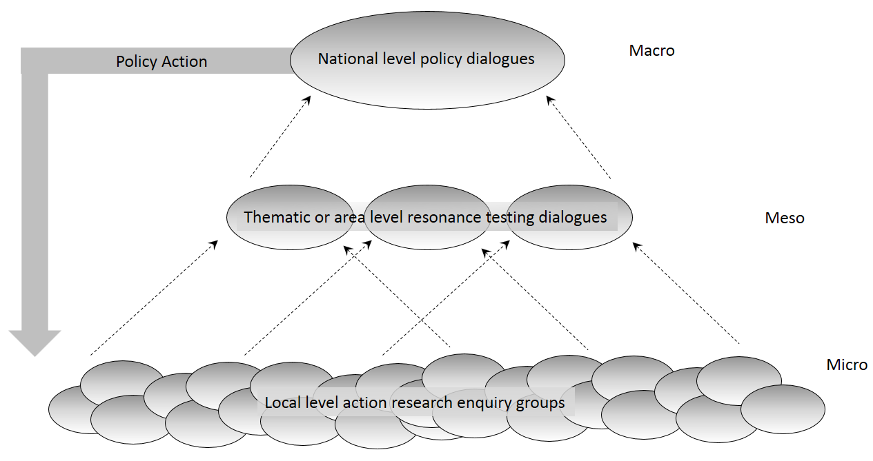
At meso level gatherings, facilitators look for resonance. When found, it is obvious and clear, and the wider group will broadly agree. Resonance tested stories can be used at a higher level, and may need to be retold in aggregate to reflect their resonant nature. It is these that are used to pass evidence to the macro-level dialogue processes. Resonance testing groups can meet approximately once every 4 to 6 months in time to feed their findings upwards.
Figure 3

Macro Level Dialogues
At the national level, GEC partners will form national policy platforms. Here, national policy makers and influencers are invited to participate in an action research exercise where they agree to engage in their own defined Green Economy actions using evidence received through micro dialogues and resonance tested meso dialogues. Their commitment is that they agree to take some kind of action on the basis of the evidence that they receive. This does not preclude them from taking other kinds of action.
As they pull policy levers, they will have a greater or lesser effect on the micro level. This effect will generate new experiences at the micro level, and evidence will rise, be resonance tested and presented back to them within a relatively short time frame. This provides unique incentive for as live policy feedback mechanism.

Global Level Dialogues
As this process begins to deliver evidence in partner countries, the GEC will take key policy findings to international forums to inform wider global knowledge. This will principally occur through GEC members, through documentation and specific policy papers for global forums.

Downward Knowledge Flow
The emphasis of dialogues is to engage citizens and policy makers in action in accordance with principles of Green Economy. Substantial knowledge exists from experiences around the world, and within focused expert institutions. While GEC dialogues strongly emphasise generating and sharing local knowledge, the processes described also present opportunity to present global findings to action groups and policy forums. It is important however that we continually recognise that external knowledge must be contextualised. Local social, political, economic and ecological dynamics will combine in ways that are unique rendering absolute positions unworkable. Therefore, micro, meso and macro forums will be regularly presented with global learnings judiciously selected as being potentially appropriate, in a bid to inform actions selected locally and nationally.

Mapping out Systems
Before we engage in any complex system, we need to be able to see it. If we want to get an accurate picture of that system as perceived by many different stakeholders, we first need to find out what they know about that system, and then put it together in a way that is informative to everyone. This process is called Participatory Systemic Inquiry (PSI) which is a foundational inquiry. It provides a comprehensive starting point on critical issues that need to be resolved and the system dynamics which underpin them. It lays down a base line depiction of inter-relationships which can be interrogated and adapted over time. This can then feed into local action, programmes and even research. PSI documents interrelations by mapping these out in a process that is rooted in the experience of people who principally benefit from the inquiry. The analysis is done by them and their peers.

Some important principles

Systems need to be seen from multiple perspectives:
Any system is seen differently by everyone. The connections they see, the parts of the system that they see and their interpretation of what is important are all different. To understand how a system works, it is important to see it from multiple perspectives and to juxtapose these to discern what people see in common and what they see differently. These differences can be described in system maps, and debated over. Maps can be compared and patterns identified. Seeing systems from multiple perspectives drives innovation and change.

Inquiry process itself may involve multiple methods
There are many ways to collect data for maps, ranging from observation, conversation, secondary data review, transect walks and more. The important feature here is less about the data itself, and more about who analysed it, and how. It is important to continually question whether we have the information we need to understand what we are looking at.

It is necessary to subject meaning making to collective scrutiny
To build a helpful picture of collective subjectivity, it is important to ensure that there is collective analysis by people from across the system. It is not enough to just collect data from different parts of the system. Each stage of analysis should be conducted by people from across the system because it is only by understanding multiple interpretations of what is happening that people can see how change might happen. It is also vital for ‘ownership’.

Systemic mapping
System maps are collectively crafted documents that allow the whole to be seen in one place, show connections between things and encourage dialogue and analysis. Participatory creation of maps captures wide perspective and creates high levels of engagement and energy, which in turn builds ownership and impetus for action. Without mapping them, it is very hard to see complex interdependencies between issues, associated stakeholders and the attractors that hold system patterns in place.

The mapping process involves four key elements
- Multi-stakeholder inquiry
- Construction and analysis of large messy maps of issues and systemic relationships
- Construction and analysis of distilled system dynamic maps
- Validation and resonance processes

System dynamics constantly change, and this needs to be captured:
Systems are constantly changing. Every move within a system creates a change in that system. This might be small and localised, or a domino effect that ripples through the system. As multiple changes interact, the system changes in ever more unpredictable ways. The system today is different to the system in a few months’ time. Mapping this is a first step. We also to identify dynamic change. Even though change in a system is continuous, underlying dynamics do not necessarily change. System mapping aims to understand system dynamics as the basis for creating sustainable change. While we can easily create changes within a system, it is difficult to create sustainable change. System maps help us look at changes over time and see system dynamics.

Stage 1: Multi-stakeholder inquiry
The aim of multi-stakeholder inquiry is to build pictures of issues, actors (people and organisations) and the inter-relationships between them. Here we seek to develop insight into problems, why they emerge, how they are maintained, and how they become entrenched. While we can never see the whole system, we can usually reveal the most important relationships. Once we can see the ways in which different parts of the system influence each other it is easier to think about sustainable responses to those issues.

Most development interventions define problems in terms of deficits (lack of skills, lack of information, deficient understanding, poor infrastructure). This naturally leads to the implementation of pre-supposed solutions. Participatory Systemic Inquiry by contrast does not rely on assumptions about “what isn’t.” Rather it tries to establish “what is” as a platform for generating solutions. It
- engages people on real issues that they experience by asking open questions which elicit what they think is important,
- creates pictures of the whole so that gaps and opportunities can be visually identified
- develops real time theories of change
- works to foster action on these
- asks critical questions and challenge assumptions that restrict possibilities for action, and
- nurtures many lines of response in ways that allow for complex dynamics to appear and inform solutions.
Who should be engaged in the inquiry process?
The purpose of inquiry is to get a deep understanding of key issues facing people in their localities and associated dynamics. The aim is to identify issues and find out everything about what is happening, how, why, where and with whom it is happening. Inquiry is conducted with stakeholders and other people who have influence in the situation. Once stakeholders are engaged, issues emerge that enable us to identify new ones. The process involves a constant interplay between stakeholders and issues.
For example, a discussion with a local entrepreneur might identify the local bank as a crucial location for inquiry. This might in turn identify a place where there is a high concentration of loan defaults resulting from persistent drought, which might warrant further inquiry. Alternatively, this might suggest a route of exploring why the bank is unable to offer different types of loan. There might also be knowledgeable people who are not stakeholders, but who can be helpful. For example, a shop keeper may notice a repeated pattern of behaviour or activity which no one else sees. It is also important to ensure that this knowledge is brought into the inquiry.
Frequently important sites for inquiry can be discovered simply by walking around (sometimes referred to as transect walks). We might discover unknown local organisations from street signs; uncover domestic practices or paradoxical consumer behaviour; or observe that many small shops are closed. Most meetings or group discussions can be arranged at very short notice, which limits pre-prepared responses and the extent to which groups can be controlled by dominant voices, and allows for responses to issues that have emerged very recently. Inquiry teams should be flexible and opportunistic and adapt as opportunities arise. For instance, it might become immediately expedient to split teams to chase up different lines of inquiry. Some thought therefore should be given to transport and translation options that allow for this.

There are four types of people that inquiry teams should explicitly aim to engage.
- People in representative, leadership or authority positions.
- Local people that inquiries “come across”
- Hidden people (disabled, women, poor, informal settlement residents etc.)
- Peers (people “like us” – who can offer perspective)

Engaging such people ensures that a systemic picture is built from diverse corners of the system. This is important in gaining multiple perspectives from multiple stances. Sometimes, in looking at specific issues, it might seem obvious who should be involved. However, inquiry processes frequently reveal that the key issue in the inquiry is often not what was originally thought. The process of systemic inquiry usually involves a lot of people. Inquiry teams are typically between 12 and 20 people.
Inquiry facilitation and recording
Inquiry facilitation uses a conversation approach with open prompts that are intended to enable people to tell the stories that they want to tell, within the broad boundaries of the inquiry. It is different to interview questioning or focus group facilitation. Whereas interview or focus group questioning seek responses to pre-constructed framing based on researcher assumptions, inquiries offer space for stakeholders to tell their stories and reveal new and important issues that are most important to them. In discerning this, we need to find out what people feel, what issues and analysis “resonate” with them, and what they feel passionate about.

Detailed notes need to be taken of each meeting. It is very important to catch issues as far as possible in the words of those that say them. When summarising a narrative, it is easy to place a “researcher” interpretation on it, or screen out detail leaving only a headline issue without the detail to follow through later. Expect a considerable quantity of notes at the end of a process. Typically, a one and a half hours discussion might generate ten pages of notes.

Having recorded a story or a discussion, facilitators should record their own reflections but keep these separate to the story. They might reflect on

- What facts do we need? This may be technical, legal, behavioural or financial information that we can find out after the story has been told
- Have issues been mentioned which could be explored further? (to be done after they have told their stories).
- What do we observe? What can we see in front of us that is significant?
- What conflicts, or conflicts of interest are there?
- What differences in perception are there in relation to others we have inquired with?
- What underlying assumptions seem to be guiding the opinions, behaviours and actions of the group, to what extent are they contestable?
- Were there possible opportunities emerging from the conversation which could be explored further?
Finally, in observing situations it is crucial to think about who and what is not present as well as what is present.

Stage 2: Construction and analysis of ‘messy’ issue and relationship maps

Analysing the stories
The next step is to turn multiple stories into a coherent picture of what is going on. We can do this by creating system maps. Whether the raw material for the maps is life stories or dialogue reports or interviews, the first stage in the process is to analyse them. One way to do this is to form pairs of people and divide stories amongst them and to ask “what are the most important factors about this story and why is it important” and “what are the causes and consequences of each factor?”

Creating messy maps
Once stories are analysed, we ask people to map factors that they have identified and the relationships between them. The aim of the maps is to understand the complex dynamics of the system. This is not a stakeholder mapping exercise, rather it is an issue mapping exercise upon which stakeholders become apparent.
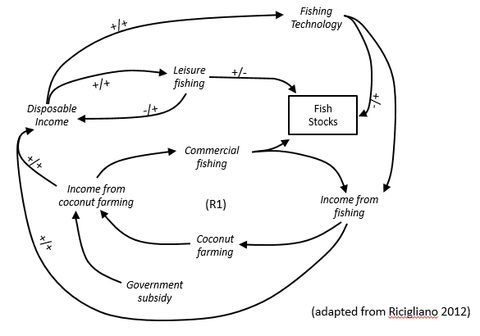
The primary focus of the maps is issues and we are mapping the different factors of which they are comprised. Participants mark relationships with directional arrows showing causality. Formal system mapping involves marking each relationship with a + or a -. Using this method +/+ means that an increase in one factor leads to an increase in the other; +/- means that an increase in one factor leads to a decrease in the other; -/+ means that a decrease in one factor leads to an increase in the other; and -/- means that a decrease in one factor leads to a decrease in the other.

This helps see the effects of relationships. However this is often too complicated to use in community situations where people have had little formal education. Here, we can use a different protocol whereby arrows in red denote negative relationships and arrows in black denote positive relationships.

Doing it this way means that all the key linkages from all the stories can be depicted in one place in a very short space of time. The point of these maps is to take the knowledge from all the different parts of the inquiry and depict it on a single canvas. Each pair or small group holds part of the picture and brings it together with the others to create the whole. Once their part is on the map, it is subject to collective scrutiny so it is not only their analysis that is applied to it. Later parts of the map can be taken out, distilled and neatened up.

The first step is for participants to put up a canvas of white paper on a large wall. We can do this by taping 6-8 sheets of flip chart paper together. This may be up to 2 metres high and 10 metres long. Once the paper is up then everyone is encouraged to look at their notebooks and think about the interconnected chains of factors that emerged in their inquiries. They may want to start with a discussion or to get the knowledge that they are holding straight down onto the paper. One person will start to write and others will then either connect to what that person has written or start a new issue on a different part of the map. This should be a participatory process and everyone is encouraged to join in. It doesn’t matter if they get the distances wrong of make mistakes and change them. Linkages made between the issues, and supportive evidence such as quotes and facts are also put on the map. If the map needs to be bigger more sheets can be added. Sometimes we can construct single maps. Sometimes it can be a good device to construct multiple maps from different locations and then compare the differences.

In constructing maps, we need a mixture of free creativity and discipline. The main discipline is ensuring that there is agreement on a clear set of agreed colours and symbols. Different colours could denote very different things. Given that marker pens are mainly used to create the maps, and are almost universally sold in packs of four which are typically blue, black, green and red, the following protocol is my preference.

Notation | Description | Examples and notes
Red marker pen writing | Factors  Factors are actions or conditions that cause things and are caused by things | Fishing family needs to borrow money to pay for their boats. They give their eldest son to a middle man in exchange for upfront cash, which leads to the boy working for 16 hours a day. This leads to the boy getting ill. Each of these four is a factor linked by an arrow.
Blue marker pen writing | Places and People (stakeholders) | Fishing cooperative, lenders, MFIs, market traders, transporters, local government.
Green marker pen writing | Factual information or observations  Sub-factors should not be listed as bullets below main issues. They should be depicted in causal relation to each other. | Many boys in some villages have been taken to the city.  Parents received 2,000 rupees for the child  Boats cost 4,000 rupees
Small pen writing | Quotes and short illustrative stories | “I went to the market and was approached by a man I didn’t know. He offered me a mobile phone if I came to work for him”
Story codes (biro) | These are the number codes that relate to each of the stories, These can be added next to the factors in small pen.
Red arrow line | Negative pathway  Link issues with a directional arrow
Black arrow line | Positive pathway  Link issues with a directional arrow | Whether to use a red or black arrow is a matter of judgement and what starts as positive could become negative
Blue sticky note | Anything that is your idea, thought, connection  This is where you put anything that is not in the data that is being analysed | Nothing should go on the map in pen if it is not in the stories or other transcripts. Coloured sticky notes give you the chance to join the dots, ask questions, highlight gaps, propose possible solutions. What if ….
Yellow sticky note | English translation

After the first iteration of the map, facilitators may wish to ask participants if they want to make some of the lines thicker because the linkages appear in more of the accounts and stories that they have collected. They may want to mark a relationship line with an asterisk to denote points of conflict, major areas of disagreement, or blockages in the system such as those resulting from say, vested interests. Similarly, they might mark a relationship with a question mark to denote a possibility. The important point is that a key is agreed in advance and is consistent across the inquiries in different locations with different people.

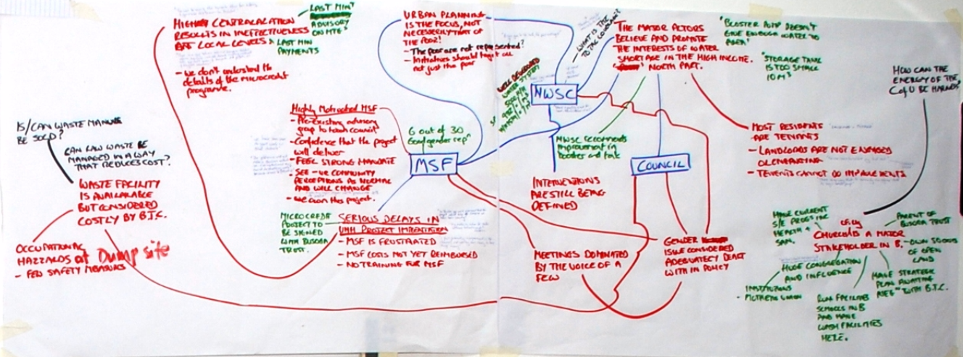

Wherever possible photographs should be taken to illustrate the context and the issues. These can be attached to the map to bring it alive.

It is crucial that we map what people say, not our own constructs or opinions. The only thing that should go onto the map should be in the stories from the ground or in the notebooks of the participatory researchers. An expert, for example, might be shocked at the state of fishing boats and map this as an issue, but it may barely get a mention because people see other things as being worthier of attention. Or an NGO staff member might think that the big issue for someone who has been indentured is that he is working 16 hours a day without the right to go to the toilet, but for that person the real issue might be that they have been separated from their sibling. This does not stop us as researchers adding our own reflections as inquiry questions, but these should be clearly distinguished from inquiry data from the field. We do this by putting sticky notes onto the maps.

Supporting quotes and stories can be added in biro or fine pens by individuals. Similarly, it should not be problematic for individuals to place factual and technical information (green) on the map once the core relationships have been laid down.

Guidelines for mapping
- Participants can put their material directly onto the map in their pairs or small groups. They need not discuss every element as a group initially, or the process will take too long. However, they will want to discuss collectively once some of the key pathways start to go onto the map.
- Participants may want to practise techniques of map drawing before they start working on the big map.
- Don’t worry if the map is messy. They may have lines criss-crossing them, depicting relationships. They will be written in multiple handwritings, some big and some small. Sometimes there will be more than one language. There will be mistakes covered up in masking tape and some elements may not end up where they logically belong. The idea is that everyone is involved. The map is as much a tool for discussion and analysis as a finished object.
- Make sure that factors are only put onto the map once. This means that you need to be aware of what else is on the map.
- Don’t write too big so there is enough space on the map. It may be clear right from the start that that there are big clusters of issues. You may want to very loosely plan where these might go on the map. The map can be cut by geography, issues, or simply be evolved organically.
- Be as specific as possible. Observation in green should define actual data wherever possible.

Analysing the maps
Once the map is drawn the next step is to collectively analyse it. When analysing we are looking for a number of things:
- Issues: What seems to be happening?
- Connections: How are these things related?
- Cause effect relationships, feedback loops etc.
- Patterns: Are there patterns that can be discerned?
- Power relationships: individual, organisational and systemic
- System dynamics and social norms: What are the factors that keep the system in balance (or not) within a particular pattern of attractors.
- Contradictions and paradoxes
- Energy: Where does the energy lie within the system?
- System change: What is changing within the system – how and why?
- Where do issues cross into what appear to be other systems?
- The unexpected: Is there anything unusual or surprising, which might reveal new ways of seeing what is going on/ challenge assumptions etc.
- Outliers and positive deviance activities that may be instructive
- Potential solutions to problems that either lie within the map or are implicit
- Opportunity points, entry points, leverage points where changes might nudge the system in the direction of solutions.

Examples of a simple cause-effect relationship might be:
- Introduction of a micro-finance institute threatens the political grip of informal lenders, which leads to vandalism of MFI outlets
- Family receives money for boys over 12 ➔ boy taken to tea shop -➔boy works 16 hours each day ➔ boy gets ill ➔ another child is sent to the city to pay the debt

Examples of patterns that we notice might be:
- It appears that girls of fishing families are least likely to be attending school.
- Older boys are more likely to be sold into indentured labour.
- There is a strong relationship between fish bombing and poor fish quality in the markets across three towns

Maps do not necessarily provide conclusive evidence. However, once we have noticed patterns, we are alerted to what we need to investigate further. All factors should be the subject of discussion and will help in the construction of the distilled system dynamics maps, which is the next stage of the process.

Stage 3: Construction of distilled system dynamic maps

The third stage of the process is to create distilled system dynamic maps. Sometime this is not always necessary if the dynamics are very clear on the big map. Distilled maps show how things relate to each other, cause each other, trigger change etc. These can depict small aspects of the system that seem ripe for working on, or they can be simplified depictions of a larger process. The focus of these maps is explicitly as the title suggests, to identify underlying system dynamics.

One important principle is that the ‘starting conditions’ have a profound effect on the dynamics that flow from them. If the starting conditions are rooted in an assumption then a particular set of system dynamics will flow from that.

While messy maps engage everyone in their creation in a fairly ad hoc way and there is no requirement for agreement on what is mapped, the distilled maps need to be agreed. A map scribe who has clear and neat handwriting should be identified at the beginning of each session. Alternatively cut out arrows and sticky notes - each with an issue written on them that can be arranged on flip chart paper and moved around.

A group may choose to develop just one or perhaps even five different system dynamics maps from the bigger messy maps.

Stage 4: Validation and resonance testing of issues

Validation is a way of checking that the data is not just the view of only a few individuals. Messy maps and distilled system dynamic maps should both be the subject of validation. People looking at the map should be able to say “yes, I recognise that pattern”, “Yes, that makes sense” or “Yes, but there is something fundamental mission” or “No! …” This can is a form of triangulation.

Validation is not about building a consensus. Usually, mapped issues arise out of tensions characterised by differential power relationships and it is unlikely that people have the same perspective. Validation ensures that the views expressed by different stakeholders are accurately represented, and that the dynamics identified by those analysing the maps have credibility to some or all of the stakeholders. Often, people will agree on what is happening even if they disagree on why. If the maps are made and analysed by the stakeholders themselves then the process of mapping is itself a validation.

One approach is to organise a validation meeting during the week of an inquiry. When participants meet people as they gather stories and data, they can invite them to attend. At the meeting, facilitators can work through the maps with the participants.

Other forms of validation and resonance testing can happen as part of a more formal iterative process. Here, a large event where the evidence from one place is analysed by people from another part of the system to see if there is resonance. Stories and data from individual local inquires brought into a bigger collective space enables horizontal validation between enquiries, and vertical validation with different levels. This enables us to see both resonance and dissonance between different levels.

Once validated, maps provide the basis for action. This can either be fed into programmes and plans, generate action directly, or form the basis of new inquiry based action research groups.

Inclusive Peace and Transition Initiative, Briefing Note: National Dialogues; January 2016
Participation is defined here as active involvement (in contrast to colloquial definitions that also include passive inclusion)
The strength of a tie is the combination of the amount of time, the emotional intensity, the intimacy and reciprocal services which characterise the tie. Granovetter, M.S (1973); The Strength of Weak Ties, American Journal of Sociology, Volume 78, Issue 6, (May 1973), 1360 - 1380
Danny Burns and Stuart Worsley, October 2015; Navigating Complexity in International Development, Facilitating Sustainable Change at Scale, Practical Action Publishing
Many traditional analysis processes define problems facing people as “lack of” something, which is tautological, assuming that the absence of the solution is in fact the problem.

